SDAT and Dev Ops QAP 1 Documentation
By Brian Jackman

- Clean code practices:

Used meaningful names to reduce need for comments
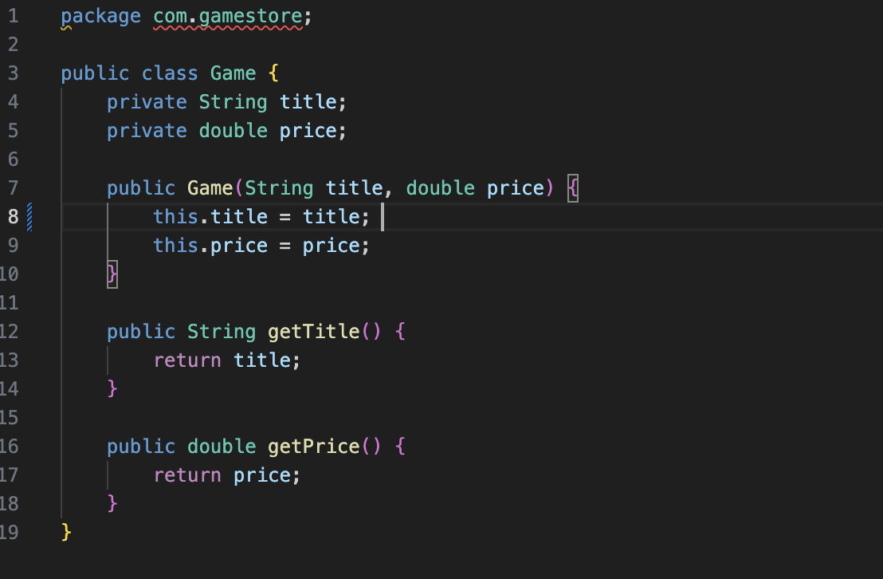
Single responsibility principle. Each class is only responsible for one job
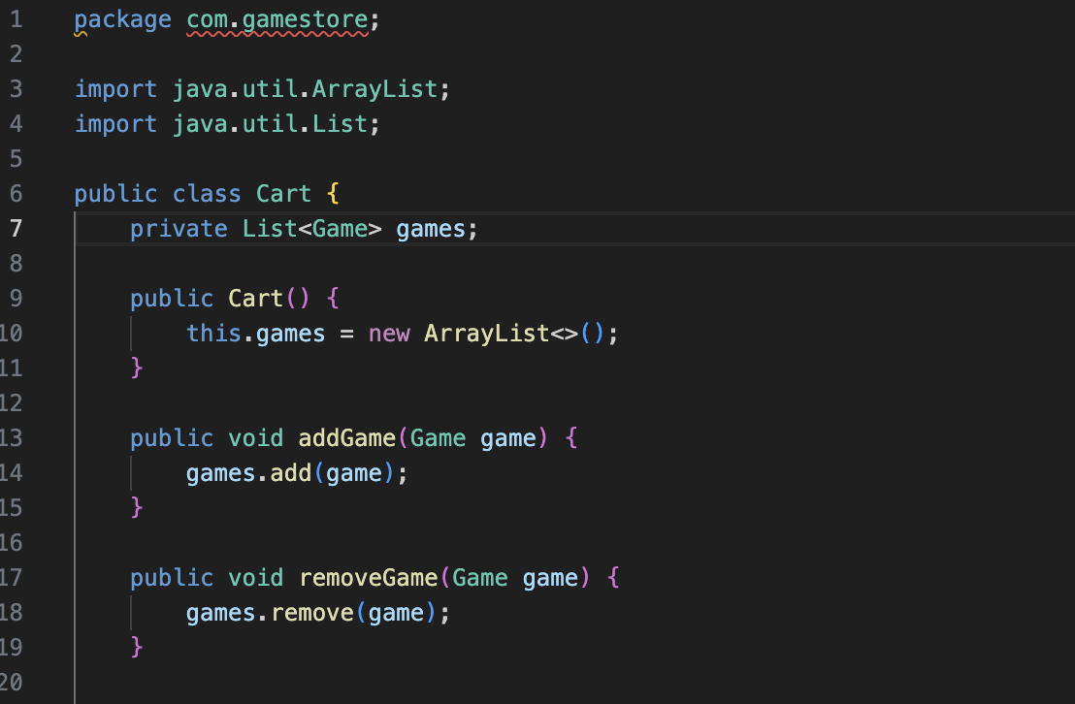

Encapsulation. Fields are private and access is provided through public methods.
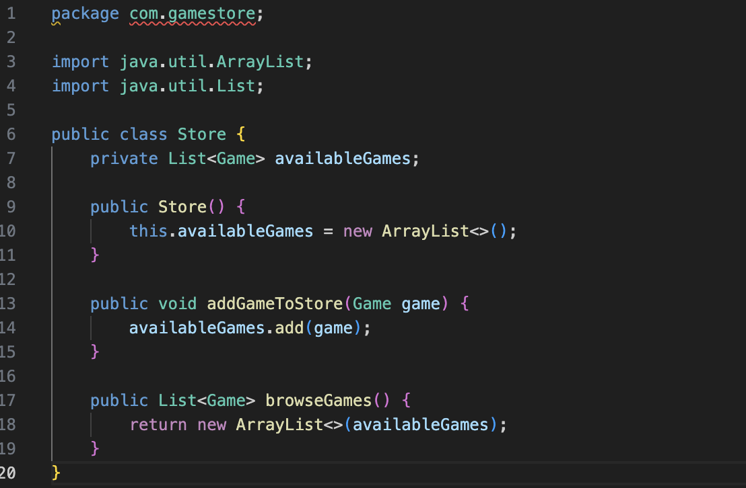

- Explanation of project:
Simple CLI based app that lets users browse games, add or remove from cart and purchase them.
The Game class represents a game that would be in the store, the Store class manages the available games, the Cart class manges games added to or removed from the cart, The Main class demonstrates how to use the other classes. The test cases test games being added ore removed from cart, calculating the total and purchase processing to validate the cart is cleared after purchase.

- Maven dependencies:
The project uses Junit 5 API, Junit 5 Engine and Maven Surefire Plugin all of which can be found on the maven central repository.

